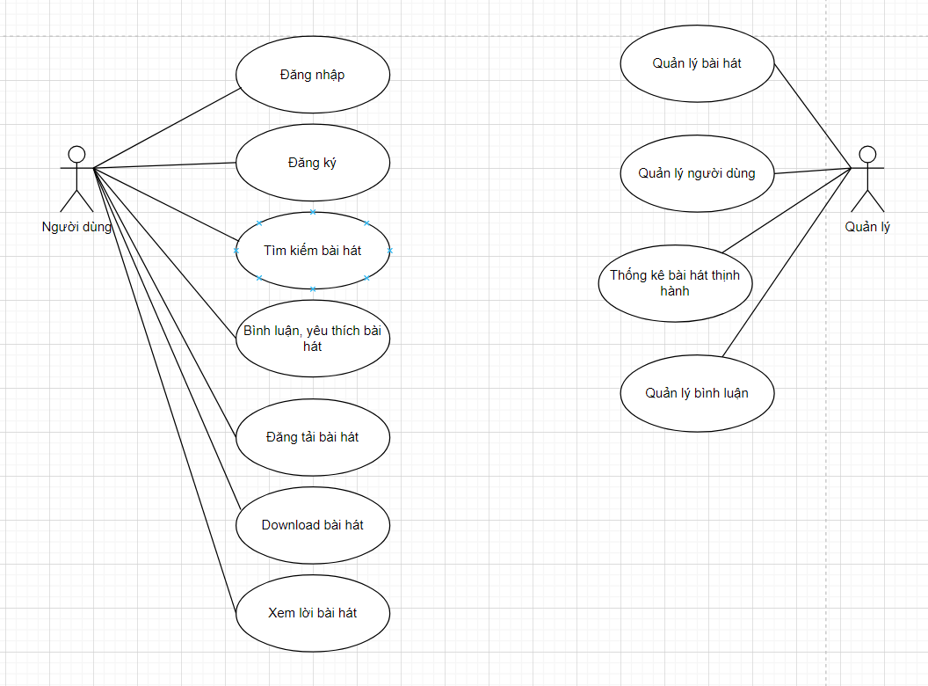

1. **Xác định thực thể**
2. -USER (Email, lastname, firstname, avatar, bio, heart_count, sdt, fb_link, tiktok_link, instagram_link, song_count, birthday, cover_image)
3. -WEBSITE (ID, link)
4. -SONG (ID, name_song, lyric, audio, song_description, avatar_song, category)
5. -COMMENT (ID, comment)
6. -FOLLOW (Id_user, id_follower)
7. -LIKE ()
8. **ERD**

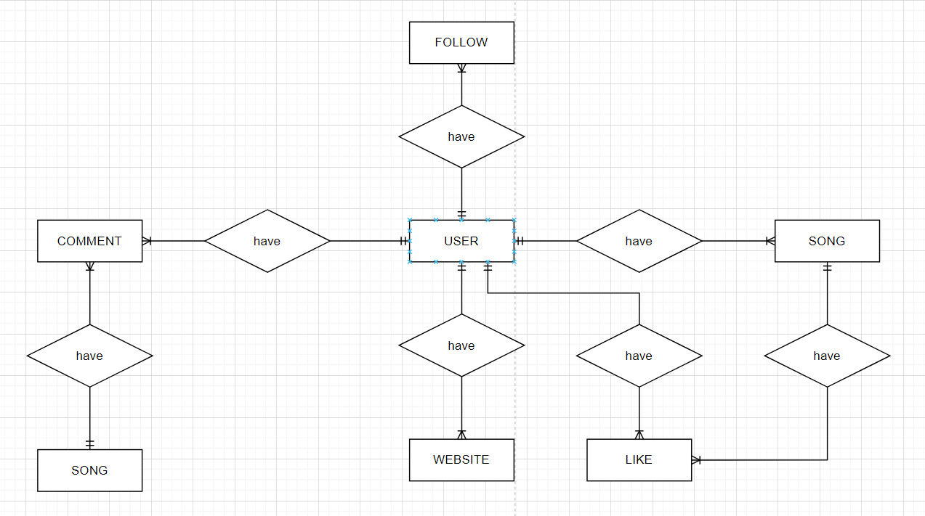

1. **Mô hình dữ liệu quan hệ:**
2. **USER** (Email, lastname, firstname, avatar, bio, heart_count, sdt, fb_link, tiktok_link, instagram_link, song_count, birthday, cover_image)
3. **WEBSITE** (link, id_user)
4. **SONG** (name_song, lyric, audio, song_description, avatar_song, category, id_user)
5. **COMMENT** (comment, id_song, id_user)
6. **FOLLOW** (id_user, id_follower)
7. **LIKE** (id_song, id_user)